VISVESVARAYA TECHNOLOGICAL UNIVERSITY


"Jnana Sangama", Belgaum -590 018, Karnataka State, India

A MINI PROJECT REPORT
ON
“SPORTS EVENT MANAGEMENT SYSTEM”

Submitted on partial fulfilment of academic requirement of 5th semester
DATABASE MANAGEMENT SYSTEM LABORATORY

BACHELOR OF ENGINEERING
IN
COMPUTER SCIENCE AND ENGINEERING

Submitted by

SNEHA
. V SEM, CSE B .
USN: 1SJ17CS083

Under the guidance of

Mr. SESHAIAH M
Assistant Professor,
Department of CSE,SJCIT
Carried out
at
DATABASE MANAGEMENT SYSTEM LABORATORY,
SJCIT



S J C INSTITUTE OF TECHNOLOGY
Department of Computer Science and Engineering
Chickaballapur – 562 101
2019-2020
|| Jai Sri Gurudev ||
Sri Adichunchanagiri Shikshana Trust
S.J.C INSTITUTE OF TECHNOLOGY
Computer Science & Engineering Department
Chickballapur-562101

CERTIFICATE
This is to certify that the Project work entitled “ SPORTS EVENT MANAGEMENT SYSTEM” is a bonafide work carried out at Database Management System Laboratory by SNEHA(1SJ17CS090) in partial fulfilment for the award of Bachelor of Engineering in Computer Science and Engineering in Fifth semester of the Visvesvaraya Technological University, Belgaum during the year 2019-20. It is certified that all corrections/suggestions indicated for Internal Assessment have been incorporated in the report deposited in the department library. The project report has been approved as it satisfies the academic requirements in respect to Fifth Semester Mini Project work prescribed for the said degree.

Signature of the Guide Signature of the HOD
Mr. Seshaiah M Dr. Anitha T.N.
Assistant Professor, Professor and HOD,
Department of CS&E,SJCIT Department of CS&E,SJCIT

External Viva:
Name of Examiners
1)
2)

ACKNOWLEDGEMENT

With Great pride I would like to convey my gratitude and appreciation to my alma-mater “S.J.C Institute of Technology” for giving me the required platform for the fulfilment of the Mini project on Database Management System as per the V.T.U requirements, for the fifth semester lab.

I express my sincere thanks to Dr. K M Ravikumar, Principal of SJCIT for providing me with excellent infrastructure and facilities to complete the project.

I express wholehearted gratitude to Dr. T N Anitha Professor and HOD of Computer Science and Engineering Department. I wish to acknowledge her help in making my task easy by providing me with her valuable help and encouragement.

It is my pleasure to thank my guides Mr. Seshaiah M., Assistant Professor, Department of Computer Science and Engineering, SJCIT for his guidance, encouragement and valuable suggestion from the beginning of the project work till the completion without which this project work would not have been accomplished. I am greatly indebted to them.

And last but not the least; I would be very pleased to express my heart full thanks to the teaching and non-teaching staff of the Department of Computer Science and Engineering, SJCIT for their motivation and support.

We also thank all those who extended their support and co-operation while bringing out this project.

SNEHA 1SJ17CS090

ABSTRACT

This project mainly aims in the process of “Courier Management System” which deals with the Courier Information System. The system is used for daily activities such as booking a courier, maintain employee details, maintain customer details, maintain shipping details etc. It is very difficult to do this process manually. Hence it is recommended to computerize the process by developing the relative software as the world is turning into information and technology, computerization becomes necessity in all walks of life.

TABLE OF CONTENTS
ABSTRACT i
ACKNOWLEDGEMENT ii
CONTENTS iii-iv
LIST OF FIGURES v
Chapter 1: Introduction 1
1.1 Introduction to project 1
1.2 Statement of the Project 1
1.3 Scope of the Project 1
Chapter 2: System Requirements 2
2.1 Hardware Requirements 2
2.2 Software requirements 2
Chapter 3: Design 3
3.1 Data flow Diagram 4
Chapter 4: Implementation 5
4.1 Algorithm 5
4.2 Source Code 5
4.3 Snapshot 19
Chapter 5: Conclusion 25

References 26

LIST OF FIGURES

Figure Number Figure Name Page Number
Figure 3.1 ER Diagram 10
Figure 5.1 Admin Login
Figure 5.2 User login 19
Figure 5.3 User register
Figure 5.4 User signup 20
Figure 5.5 Admin Services 21
Figure 5.6 User Services 21
Figure 5.7 Event Register 22
Figure 5.8 Participant Details 22
Figure 5.9 Event Details 23
Figure 5.10 Admin Customer 23

CHAPTER 1
INTRODUCTION
1.1 Introduction to Project
The Project entitled “Sports event Management System” is to develop a software product that is used in sports service to maintain their details systematically. The product is developed to maintain the participant and the sports details, and also to get the information of the status of the event. The main benefit of this project is that it facilitate user to communicate in a faster manner in comparison of manual system. Through this system the current status of the event can be known easily whereas in manual system it is a difficult task. The Admin has all rights to provide or restrict to any of the event and participant to the functionality of the event . Participant has the liberty to see all the events being conducted and can register him/her self to the any event . This Project facilitates to make calculation of the event amount and provides the provisions to cancel the registration. The project is reliable only when the database is maintained properly.

1.1 Statement of the Project
The system will be used for registration of participants listing events managing event time. Actually it is not easy to do this process manually because it would become very hectic. Hence it is recommended to automate the process by developing the relevant software as the world is moving from manual working to information and technology era where computerization becomes important in all part of life. Product Description Sports event Management System is a modular software framework for an enterprise which posses operations in domestic services. Sports event Management System performs a variety of activities pertaining to the processes in the logistic context of an event business. Sports event Management System solution handles the end to end process staring from initiating a register, providing details about event, category, registration amount. Sports event Management System covers all the controls and processes involved in Sports event. 1.3 Scope of the Project
Sports event management computerization is “the incorporate of appropriate technology to help administrator manage information. Technology is considered appropriate, when it utilizes the most abundant domestic resources and conserves capital and skilled personnel”.
This project deals with the maintenance of event list, participants list, category list, event details etc; the main aim of this project is to computerize the maintenance of Sports event management.

1
CHAPTER 2

SYSTEM REQUIREMENTS SPECIFICATION
System requirement specification (SRS) is basically an organization, which understands a customer or potential client’s system requirements and dependencies at a particular point in time prior to any actual design or development work. It’s a two-way insurance policy that assures that both the client and the organization understand the others requirements from that perspective at a given point in time.

2.1 HARDWARE REQUIREMENTS

- PROCESSOR : INTEL I5
- RAM : 4GB
- HARD DISK SPACE : 500GB
- MOUSE AND KEYBOARD

2.2 SOFTWARE REQUIREMENTS
- IDE : NETBEANS
- SERVER : MYSQL
- OPERATING SYSTEM : Windows 10
- DATABASE : MYSQL
- FRONT END : JAVA

2
CHAPTER 3
DESIGN

The process of design involves “conceiving and planning out in mind and making a drawing, pattern or a sketch”. The system design transforms a logical representation of what a given system is required to do into the physical reality during development. Important design factors such as reliability, response time, throughput of the system, maintainability, expandability etc., should be taken into account. Design constraints like cost, hardware limitations, standard compliance etc should also be dealt with. The task of system design is to take the description and associate with it a specific set of facilities-men, machines (computing and other), accommodation, etc., to provide complete specifications of a workable system.
This new system must provide for all of the essential data processing and it may also do some of those tasks identified during the work of analysis as optional extras. It must work within the imposed constraints and show improvement over the existing system. At the outset of design a choice must be made between the main approaches. Talks of “preliminary design” concerned with identification analysis and selections of the major design options are available for development and implementation of a system. These options are most readily distinguished in terms of the physical facilities to be used for the processing who or what does the work.

3
3.1 ER DIAGRAM

4

CHAPTER 4
IMPLEMENTATION

Implementation is the action that must follow any preliminary thinking in order for something to actually happen. In an information technology context, implementation encompasses all the processes involved in getting new software or hardware operating properly in its environment, including installation, configuration, running, testing, and making necessary changes. The word deployment is sometimes used to mean the same thing.
Implementation is the realization of an application, or execution of a plan, idea, model, design, specification, standard, algorithm, or policy. In computer science, an implementation is a realization of a technical specification or algorithm as a program, software component, or other computer system through programming and deployment. Many implementations may exist for a given specification or standard.
The implementation stage in a system involves:
- Careful planning.
- Investigation of the current system and the constraints on implementation.
- Training of staff in the newly developed system.
Implementation is the stage of the project when the theoretical design is turned out into a working system. Thus it can be considered to be the most critical stage in achieving a successful new system and is giving the user, confidence that the new system will work and be effective. The implementation stage involves careful planning, Investigation of the existing system and its constraints on implementation, designing of methods to achieve change over and evaluation of change over methods.
5.1 ALGORITHM
Step1: Start.
Step2: Login to the Admin or sign-in/login to the user panel.
Step3: Admin can add categories and events and participants details.
Step4: Opening the Sports event Management System.
Step5: User can login/register for events, edit his activities.
Step6: View his/her details and event details and register or unregister from event.
Step7: Logout.
Step 8: End.

5.2 SOURCE CODE

import java.sql.*;
import java.sql.Connection;
import javax.swing.JOptionPane;
import java.sql.DriverManager;
import java.sql.PreparedStatement;
import java.sql.SQLException;

5
public class userlogin extends javax.swing.JFrame {

public userlogin() {
initComponents();
}

@SuppressWarnings("unchecked")
// <editor-fold defaultstate="collapsed" desc="Generated Code">
private void initComponents() {

jPanel1 = new javax.swing.JPanel();
jLabel1 = new javax.swing.JLabel();
jLabel2 = new javax.swing.JLabel();
jLabel3 = new javax.swing.JLabel();
name = new javax.swing.JTextField();
login = new javax.swing.JButton();
reset = new javax.swing.JButton();
newregister = new javax.swing.JButton();
exit = new javax.swing.JButton();
password = new javax.swing.JPasswordField();

setDefaultCloseOperation(javax.swing.WindowConstants.EXIT_ON_CLOSE);

jPanel1.setBorder(javax.swing.BorderFactory.createLineBorder(new java.awt.Color(0, 0, 0), 2));
jPanel1.setLayout(new org.netbeans.lib.awtextra.AbsoluteLayout());

jLabel1.setFont(new java.awt.Font("Lucida Grande", 1, 24)); // NOI18N
jLabel1.setText("User Login");
jPanel1.add(jLabel1, new org.netbeans.lib.awtextra.AbsoluteConstraints(140, 30, -1, -1));

jLabel2.setText("User Name");
jPanel1.add(jLabel2, new org.netbeans.lib.awtextra.AbsoluteConstraints(80, 100, -1, -1));

jLabel3.setText("PassWord");
jPanel1.add(jLabel3, new org.netbeans.lib.awtextra.AbsoluteConstraints(80, 140, -1, -1));

name.addActionListener(new java.awt.event.ActionListener() {

6
public void actionPerformed(java.awt.event.ActionEvent evt) {

nameActionPerformed(evt);
}
});
jPanel1.add(name, new org.netbeans.lib.awtextra.AbsoluteConstraints(210, 100, 120, -1));

login.setText("Login");
login.addActionListener(new java.awt.event.ActionListener() {
public void actionPerformed(java.awt.event.ActionEvent evt) {
loginActionPerformed(evt);
}
});
jPanel1.add(login, new org.netbeans.lib.awtextra.AbsoluteConstraints(120, 180, -1, -1));

reset.setText("Reset");
reset.addActionListener(new java.awt.event.ActionListener() {
public void actionPerformed(java.awt.event.ActionEvent evt) {
resetActionPerformed(evt);
}
});
jPanel1.add(reset, new org.netbeans.lib.awtextra.AbsoluteConstraints(240, 180, -1, -1));

newregister.setText("New Register");
newregister.addActionListener(new java.awt.event.ActionListener() {
public void actionPerformed(java.awt.event.ActionEvent evt) {
newregisterActionPerformed(evt);
}
});
jPanel1.add(newregister, new org.netbeans.lib.awtextra.AbsoluteConstraints(100, 230, -1, -1));

exit.setText("back");
exit.addActionListener(new java.awt.event.ActionListener() {
public void actionPerformed(java.awt.event.ActionEvent evt) {
exitActionPerformed(evt);
}
});
7
jPanel1.add(exit, new org.netbeans.lib.awtextra.AbsoluteConstraints(240, 230, -1, -1));

password.addActionListener(new java.awt.event.ActionListener() {
public void actionPerformed(java.awt.event.ActionEvent evt) {
passwordActionPerformed(evt);
}
});
jPanel1.add(password, new org.netbeans.lib.awtextra.AbsoluteConstraints(210, 140, 120, -1));

javax.swing.GroupLayout layout = new javax.swing.GroupLayout(getContentPane());
getContentPane().setLayout(layout);
layout.setHorizontalGroup(
layout.createParallelGroup(javax.swing.GroupLayout.Alignment.LEADING)
.addGroup(layout.createSequentialGroup()
.addComponent(jPanel1, javax.swing.GroupLayout.PREFERRED_SIZE, 448, javax.swing.GroupLayout.PREFERRED_SIZE)
.addGap(0, 0, Short.MAX_VALUE))
);
layout.setVerticalGroup(
layout.createParallelGroup(javax.swing.GroupLayout.Alignment.LEADING)
.addGroup(layout.createSequentialGroup()
.addComponent(jPanel1, javax.swing.GroupLayout.PREFERRED_SIZE, 344, javax.swing.GroupLayout.PREFERRED_SIZE)
.addGap(0, 0, Short.MAX_VALUE))
);

pack();
}// </editor-fold>

private void exitActionPerformed(java.awt.event.ActionEvent evt) {
new welcomepage().setVisible(true);
this.dispose();// TODO add your handling code here:
}

private void resetActionPerformed(java.awt.event.ActionEvent evt) {
name.setText(null);
password.setText(null);// TODO add your handling code here:
}

8
private void passwordActionPerformed(java.awt.event.ActionEvent evt) {
// TODO add your handling code here:
}

private void loginActionPerformed(java.awt.event.ActionEvent evt) {
try{
//Class.forName("com.mysql.jdbc.Driver").newInstance();

Connection con;
con = (Connection) DriverManager.getConnection("jdbc:mysql://localhost:3306/sports?","root","sneha137137");

String query="select username1,password from userdetails where username1= '"+name.getText()+"' ";
PreparedStatement statement = con.prepareStatement(query);
ResultSet result =statement.executeQuery();
if(result.next()){
String dbasepassword=result.getString("password").toString().trim();
String enteredpasword=password.getText().trim();
if(dbasepassword.equals(enteredpasword))
{ new sdetails().setVisible(true);
this.setVisible(false);
}
else
JOptionPane.showMessageDialog(null,"invalid password");
statement.close();
con.close();
}
}
catch(SQLException se){
JOptionPane.showMessageDialog(null,se);
}

}

private void nameActionPerformed(java.awt.event.ActionEvent evt) {
// TODO add your handling code here:
}

private void newregisterActionPerformed(java.awt.event.ActionEvent evt) {

9
new register().setVisible(true);
this.dispose();// TODO add your handling code here:
}

//<editor-fold defaultstate="collapsed" desc=" Look and feel setting code (optional) ">

try {
for (javax.swing.UIManager.LookAndFeelInfo info : javax.swing.UIManager.getInstalledLookAndFeels()) {
if ("Nimbus".equals(info.getName())) {
javax.swing.UIManager.setLookAndFeel(info.getClassName());
break;
}
}
} catch (ClassNotFoundException ex) {
java.util.logging.Logger.getLogger(userlogin.class.getName()).log(java.util.logging.Level.SEVERE, null, ex);
} catch (InstantiationException ex) {
java.util.logging.Logger.getLogger(userlogin.class.getName()).log(java.util.logging.Level.SEVERE, null, ex);
} catch (IllegalAccessException ex) {
java.util.logging.Logger.getLogger(userlogin.class.getName()).log(java.util.logging.Level.SEVERE, null, ex);
} catch (javax.swing.UnsupportedLookAndFeelException ex) {
java.util.logging.Logger.getLogger(userlogin.class.getName()).log(java.util.logging.Level.SEVERE, null, ex);
}
//</editor-fold>
java.awt.EventQueue.invokeLater(new Runnable() {
public void run() {
new userlogin().setVisible(true);
}
});
}

// Variables declaration - do not modify

10
private javax.swing.JButton exit;
private javax.swing.JLabel jLabel1;
private javax.swing.JLabel jLabel2;
private javax.swing.JLabel jLabel3;
private javax.swing.JPanel jPanel1;
private javax.swing.JButton login;
private javax.swing.JTextField name;
private javax.swing.JButton newregister;
private javax.swing.JPasswordField password;
private javax.swing.JButton reset;
// End of variables declaration
}

-- MySQL dump 10.13 Distrib 5.7.17, for macos10.12 (x86_64)
--
-- Host: localhost Database: sports
-- ------------------------------------------------------
-- Server version 5.7.27

/*!40101 SET @OLD_CHARACTER_SET_CLIENT=@@CHARACTER_SET_CLIENT */;
/*!40101 SET @OLD_CHARACTER_SET_RESULTS=@@CHARACTER_SET_RESULTS */;
/*!40101 SET @OLD_COLLATION_CONNECTION=@@COLLATION_CONNECTION */;
/*!40101 SET NAMES utf8 */;
/*!40103 SET @OLD_TIME_ZONE=@@TIME_ZONE */;
/*!40103 SET TIME_ZONE='+00:00' */;
/*!40014 SET @OLD_UNIQUE_CHECKS=@@UNIQUE_CHECKS, UNIQUE_CHECKS=0 */;
/*!40014 SET @OLD_FOREIGN_KEY_CHECKS=@@FOREIGN_KEY_CHECKS, FOREIGN_KEY_CHECKS=0 */;
/*!40101 SET @OLD_SQL_MODE=@@SQL_MODE, SQL_MODE='NO_AUTO_VALUE_ON_ZERO' */;
/*!40111 SET @OLD_SQL_NOTES=@@SQL_NOTES, SQL_NOTES=0 */;

--
-- Table structure for table `admin`
--

DROP TABLE IF EXISTS `admin`;
/*!40101 SET @saved_cs_client = @@character_set_client */;
/*!40101 SET character_set_client = utf8 */;
CREATE TABLE `admin` (
`aid` smallint(6) NOT NULL,
`apassword` varchar(20) NOT NULL,
`Aname` varchar(20) NOT NULL,
`Agender` char(1) NOT NULL,
`aphone` bigint(20) NOT NULL,
PRIMARY KEY (`aid`),

11
UNIQUE KEY `Aname` (`Aname`)
) ENGINE=InnoDB DEFAULT CHARSET=latin1;
/*!40101 SET character_set_client = @saved_cs_client */;

--
-- Dumping data for table `admin`
--

LOCK TABLES `admin` WRITE;
/*!40000 ALTER TABLE `admin` DISABLE KEYS */;
INSERT INTO `admin` VALUES (1,'sneha137','sneha','f',9110852902),(2,'Sneha!23','meow','f',9876543211),(3,'Sneha!23','vevwv','f',9887655441),(4,'Sneha!23','yr','f',9876543212),(5,'Sneha!23','dawfaw','m',9876543219);
/*!40000 ALTER TABLE `admin` ENABLE KEYS */;
UNLOCK TABLES;
/*!40103 SET TIME_ZONE=@OLD_TIME_ZONE */;

/*!40101 SET SQL_MODE=@OLD_SQL_MODE */;
/*!40014 SET FOREIGN_KEY_CHECKS=@OLD_FOREIGN_KEY_CHECKS */;
/*!40014 SET UNIQUE_CHECKS=@OLD_UNIQUE_CHECKS */;
/*!40101 SET CHARACTER_SET_CLIENT=@OLD_CHARACTER_SET_CLIENT */;
/*!40101 SET CHARACTER_SET_RESULTS=@OLD_CHARACTER_SET_RESULTS */;
/*!40101 SET COLLATION_CONNECTION=@OLD_COLLATION_CONNECTION */;
/*!40111 SET SQL_NOTES=@OLD_SQL_NOTES */;

-- Dump completed on 2019-11-25 12:37:34

-- MySQL dump 10.13 Distrib 5.7.17, for macos10.12 (x86_64)
--
-- Host: localhost Database: sports
-- ------------------------------------------------------
-- Server version 5.7.27

/*!40101 SET @OLD_CHARACTER_SET_CLIENT=@@CHARACTER_SET_CLIENT */;
/*!40101 SET @OLD_CHARACTER_SET_RESULTS=@@CHARACTER_SET_RESULTS */;
/*!40101 SET @OLD_COLLATION_CONNECTION=@@COLLATION_CONNECTION */;
/*!40101 SET NAMES utf8 */;
/*!40103 SET @OLD_TIME_ZONE=@@TIME_ZONE */;
/*!40103 SET TIME_ZONE='+00:00' */;
/*!40014 SET @OLD_UNIQUE_CHECKS=@@UNIQUE_CHECKS, UNIQUE_CHECKS=0 */;
/*!40014 SET @OLD_FOREIGN_KEY_CHECKS=@@FOREIGN_KEY_CHECKS, FOREIGN_KEY_CHECKS=0 */;
/*!40101 SET @OLD_SQL_MODE=@@SQL_MODE, SQL_MODE='NO_AUTO_VALUE_ON_ZERO' */;
/*!40111 SET @OLD_SQL_NOTES=@@SQL_NOTES, SQL_NOTES=0 */;

--
-- Table structure for table `category`
--

12
DROP TABLE IF EXISTS `category`;
/*!40101 SET @saved_cs_client = @@character_set_client */;
/*!40101 SET character_set_client = utf8 */;
CREATE TABLE `category` (
`cid` smallint(6) NOT NULL,
`cname` varchar(20) DEFAULT NULL,
PRIMARY KEY (`cid`)
) ENGINE=InnoDB DEFAULT CHARSET=latin1;
/*!40101 SET character_set_client = @saved_cs_client */;

--
-- Dumping data for table `category`
--

LOCK TABLES `category` WRITE;
/*!40000 ALTER TABLE `category` DISABLE KEYS */;
INSERT INTO `category` VALUES (1,'vedio game'),(2,'mind'),(3,'physical'),(4,'coordination'),(5,'motorized');
/*!40000 ALTER TABLE `category` ENABLE KEYS */;
UNLOCK TABLES;
/*!40103 SET TIME_ZONE=@OLD_TIME_ZONE */;

/*!40101 SET SQL_MODE=@OLD_SQL_MODE */;
/*!40014 SET FOREIGN_KEY_CHECKS=@OLD_FOREIGN_KEY_CHECKS */;
/*!40014 SET UNIQUE_CHECKS=@OLD_UNIQUE_CHECKS */;
/*!40101 SET CHARACTER_SET_CLIENT=@OLD_CHARACTER_SET_CLIENT */;
/*!40101 SET CHARACTER_SET_RESULTS=@OLD_CHARACTER_SET_RESULTS */;
/*!40101 SET COLLATION_CONNECTION=@OLD_COLLATION_CONNECTION */;
/*!40111 SET SQL_NOTES=@OLD_SQL_NOTES */;

-- Dump completed on 2019-11-25 12:37:34
-- MySQL dump 10.13 Distrib 5.7.17, for macos10.12 (x86_64)
--
-- Host: localhost Database: sports
-- ------------------------------------------------------
-- Server version 5.7.27

/*!40101 SET @OLD_CHARACTER_SET_CLIENT=@@CHARACTER_SET_CLIENT */;
/*!40101 SET @OLD_CHARACTER_SET_RESULTS=@@CHARACTER_SET_RESULTS */;
/*!40101 SET @OLD_COLLATION_CONNECTION=@@COLLATION_CONNECTION */;
/*!40101 SET NAMES utf8 */;
/*!40103 SET @OLD_TIME_ZONE=@@TIME_ZONE */;
/*!40103 SET TIME_ZONE='+00:00' */;
/*!40014 SET @OLD_UNIQUE_CHECKS=@@UNIQUE_CHECKS, UNIQUE_CHECKS=0 */;
/*!40014 SET @OLD_FOREIGN_KEY_CHECKS=@@FOREIGN_KEY_CHECKS, FOREIGN_KEY_CHECKS=0 */;
/*!40101 SET @OLD_SQL_MODE=@@SQL_MODE, SQL_MODE='NO_AUTO_VALUE_ON_ZERO' */;
/*!40111 SET @OLD_SQL_NOTES=@@SQL_NOTES, SQL_NOTES=0 */;

13
--
-- Table structure for table `event`
--

DROP TABLE IF EXISTS `event`;
/*!40101 SET @saved_cs_client = @@character_set_client */;
/*!40101 SET character_set_client = utf8 */;
CREATE TABLE `event` (
`eid` smallint(6) NOT NULL,
`ename` varchar(20) DEFAULT NULL,
`regfee` smallint(6) DEFAULT NULL,
`etime` time DEFAULT NULL,
`aid` smallint(6) DEFAULT NULL,
`cid` smallint(6) DEFAULT NULL,
PRIMARY KEY (`eid`)
) ENGINE=InnoDB DEFAULT CHARSET=latin1;
/*!40101 SET character_set_client = @saved_cs_client */;

--
-- Dumping data for table `event`
--

LOCK TABLES `event` WRITE;
/*!40000 ALTER TABLE `event` DISABLE KEYS */;
INSERT INTO `event` VALUES (1,'chess',200,'09:30:00',1,1);
/*!40000 ALTER TABLE `event` ENABLE KEYS */;
UNLOCK TABLES;
/*!40103 SET TIME_ZONE=@OLD_TIME_ZONE */;

/*!40101 SET SQL_MODE=@OLD_SQL_MODE */;
/*!40014 SET FOREIGN_KEY_CHECKS=@OLD_FOREIGN_KEY_CHECKS */;
/*!40014 SET UNIQUE_CHECKS=@OLD_UNIQUE_CHECKS */;
/*!40101 SET CHARACTER_SET_CLIENT=@OLD_CHARACTER_SET_CLIENT */;
/*!40101 SET CHARACTER_SET_RESULTS=@OLD_CHARACTER_SET_RESULTS */;
/*!40101 SET COLLATION_CONNECTION=@OLD_COLLATION_CONNECTION */;
/*!40111 SET SQL_NOTES=@OLD_SQL_NOTES */;

-- Dump completed on 2019-11-25 12:37:34
-- MySQL dump 10.13 Distrib 5.7.17, for macos10.12 (x86_64)
--
-- Host: localhost Database: sports
-- ------------------------------------------------------
-- Server version 5.7.27

/*!40101 SET @OLD_CHARACTER_SET_CLIENT=@@CHARACTER_SET_CLIENT */;
/*!40101 SET @OLD_CHARACTER_SET_RESULTS=@@CHARACTER_SET_RESULTS */;
/*!40101 SET @OLD_COLLATION_CONNECTION=@@COLLATION_CONNECTION */;
/*!40101 SET NAMES utf8 */;
/*!40103 SET @OLD_TIME_ZONE=@@TIME_ZONE */;

14
/*!40103 SET TIME_ZONE='+00:00' */;
/*!40014 SET @OLD_UNIQUE_CHECKS=@@UNIQUE_CHECKS, UNIQUE_CHECKS=0 */;
/*!40014 SET @OLD_FOREIGN_KEY_CHECKS=@@FOREIGN_KEY_CHECKS, FOREIGN_KEY_CHECKS=0 */;
/*!40101 SET @OLD_SQL_MODE=@@SQL_MODE, SQL_MODE='NO_AUTO_VALUE_ON_ZERO' */;
/*!40111 SET @OLD_SQL_NOTES=@@SQL_NOTES, SQL_NOTES=0 */;

--
-- Table structure for table `PARTICIPANT`
--

DROP TABLE IF EXISTS `PARTICIPANT`;
/*!40101 SET @saved_cs_client = @@character_set_client */;
/*!40101 SET character_set_client = utf8 */;
CREATE TABLE `PARTICIPANT` (
`pid` smallint(6) NOT NULL,
`college` varchar(20) NOT NULL,
`pgender` char(1) NOT NULL,
`page` smallint(6) NOT NULL,
`pname` varchar(20) NOT NULL,
`uid` tinyint(3) NOT NULL,
`pphone` bigint(20) NOT NULL,
PRIMARY KEY (`pid`),
UNIQUE KEY `uid` (`uid`)
) ENGINE=InnoDB DEFAULT CHARSET=latin1;
/*!40101 SET character_set_client = @saved_cs_client */;

--
-- Dumping data for table `PARTICIPANT`
--

LOCK TABLES `PARTICIPANT` WRITE;
/*!40000 ALTER TABLE `PARTICIPANT` DISABLE KEYS */;
INSERT INTO `PARTICIPANT` VALUES (1,'sjcit','f',20,'sneha',1,9110852902),(3,'sjcit','f',20,'sowndaryaa',3,9110852802),(4,'sjcit','f',20,'aishu',4,9876543219),(5,'sjcit','f',20,'sadiqa',5,9876543219),(6,'sjcit','f',20,'shravani',6,9876543219),(7,'sjcit','m',20,'narsim',7,8678678676),(8,'sjcit','m',20,'skffk',8,9876543219);
/*!40000 ALTER TABLE `PARTICIPANT` ENABLE KEYS */;
UNLOCK TABLES;
/*!40103 SET TIME_ZONE=@OLD_TIME_ZONE */;

/*!40101 SET SQL_MODE=@OLD_SQL_MODE */;
/*!40014 SET FOREIGN_KEY_CHECKS=@OLD_FOREIGN_KEY_CHECKS */;
/*!40014 SET UNIQUE_CHECKS=@OLD_UNIQUE_CHECKS */;
/*!40101 SET CHARACTER_SET_CLIENT=@OLD_CHARACTER_SET_CLIENT */;
/*!40101 SET CHARACTER_SET_RESULTS=@OLD_CHARACTER_SET_RESULTS */;
/*!40101 SET COLLATION_CONNECTION=@OLD_COLLATION_CONNECTION */;
/*!40111 SET SQL_NOTES=@OLD_SQL_NOTES */;

15
-- Dump completed on 2019-11-25 12:37:34
-- MySQL dump 10.13 Distrib 5.7.17, for macos10.12 (x86_64)
--
-- Host: localhost Database: sports
-- ------------------------------------------------------
-- Server version 5.7.27

/*!40101 SET @OLD_CHARACTER_SET_CLIENT=@@CHARACTER_SET_CLIENT */;
/*!40101 SET @OLD_CHARACTER_SET_RESULTS=@@CHARACTER_SET_RESULTS */;
/*!40101 SET @OLD_COLLATION_CONNECTION=@@COLLATION_CONNECTION */;
/*!40101 SET NAMES utf8 */;
/*!40103 SET @OLD_TIME_ZONE=@@TIME_ZONE */;
/*!40103 SET TIME_ZONE='+00:00' */;
/*!40014 SET @OLD_UNIQUE_CHECKS=@@UNIQUE_CHECKS, UNIQUE_CHECKS=0 */;
/*!40014 SET @OLD_FOREIGN_KEY_CHECKS=@@FOREIGN_KEY_CHECKS, FOREIGN_KEY_CHECKS=0 */;
/*!40101 SET @OLD_SQL_MODE=@@SQL_MODE, SQL_MODE='NO_AUTO_VALUE_ON_ZERO' */;
/*!40111 SET @OLD_SQL_NOTES=@@SQL_NOTES, SQL_NOTES=0 */;

--
-- Table structure for table `pregistred`
--

DROP TABLE IF EXISTS `pregistred`;
/*!40101 SET @saved_cs_client = @@character_set_client */;
/*!40101 SET character_set_client = utf8 */;
CREATE TABLE `pregistred` (
`pid` smallint(6) DEFAULT NULL,
`cid` smallint(6) DEFAULT NULL,
`eid` smallint(6) DEFAULT NULL
) ENGINE=InnoDB DEFAULT CHARSET=latin1;
/*!40101 SET character_set_client = @saved_cs_client */;

--
-- Dumping data for table `pregistred`
--

LOCK TABLES `pregistred` WRITE;
/*!40000 ALTER TABLE `pregistred` DISABLE KEYS */;
/*!40000 ALTER TABLE `pregistred` ENABLE KEYS */;
UNLOCK TABLES;
/*!40103 SET TIME_ZONE=@OLD_TIME_ZONE */;

/*!40101 SET SQL_MODE=@OLD_SQL_MODE */;
/*!40014 SET FOREIGN_KEY_CHECKS=@OLD_FOREIGN_KEY_CHECKS */;
/*!40014 SET UNIQUE_CHECKS=@OLD_UNIQUE_CHECKS */;
/*!40101 SET CHARACTER_SET_CLIENT=@OLD_CHARACTER_SET_CLIENT */;
/*!40101 SET CHARACTER_SET_RESULTS=@OLD_CHARACTER_SET_RESULTS */;

16
/*!40101 SET COLLATION_CONNECTION=@OLD_COLLATION_CONNECTION */;
/*!40111 SET SQL_NOTES=@OLD_SQL_NOTES */;

-- Dump completed on 2019-11-25 12:37:34
-- MySQL dump 10.13 Distrib 5.7.17, for macos10.12 (x86_64)
--
-- Host: localhost Database: sports
-- ------------------------------------------------------
-- Server version 5.7.27

/*!40101 SET @OLD_CHARACTER_SET_CLIENT=@@CHARACTER_SET_CLIENT */;
/*!40101 SET @OLD_CHARACTER_SET_RESULTS=@@CHARACTER_SET_RESULTS */;
/*!40101 SET @OLD_COLLATION_CONNECTION=@@COLLATION_CONNECTION */;
/*!40101 SET NAMES utf8 */;
/*!40103 SET @OLD_TIME_ZONE=@@TIME_ZONE */;
/*!40103 SET TIME_ZONE='+00:00' */;
/*!40014 SET @OLD_UNIQUE_CHECKS=@@UNIQUE_CHECKS, UNIQUE_CHECKS=0 */;
/*!40014 SET @OLD_FOREIGN_KEY_CHECKS=@@FOREIGN_KEY_CHECKS, FOREIGN_KEY_CHECKS=0 */;
/*!40101 SET @OLD_SQL_MODE=@@SQL_MODE, SQL_MODE='NO_AUTO_VALUE_ON_ZERO' */;
/*!40111 SET @OLD_SQL_NOTES=@@SQL_NOTES, SQL_NOTES=0 */;

--
-- Table structure for table `userdetails`
--

DROP TABLE IF EXISTS `userdetails`;
/*!40101 SET @saved_cs_client = @@character_set_client */;
/*!40101 SET character_set_client = utf8 */;
CREATE TABLE `userdetails` (
`username1` varchar(20) NOT NULL,
`password` varchar(20) NOT NULL,
`uid` tinyint(3) DEFAULT NULL,
PRIMARY KEY (`username1`)
) ENGINE=InnoDB DEFAULT CHARSET=latin1;
/*!40101 SET character_set_client = @saved_cs_client */;

--
-- Dumping data for table `userdetails`
--

LOCK TABLES `userdetails` WRITE;
/*!40000 ALTER TABLE `userdetails` DISABLE KEYS */;
INSERT INTO `userdetails` VALUES ('aishu','sneha137137',4),('sadi','12345678',5),('sdf','12345678',7),('shavni','12345678',6),('sneha','12345678',1),('sonu','Sneha!23',7);
/*!40000 ALTER TABLE `userdetails` ENABLE KEYS */;
UNLOCK TABLES;
/*!40103 SET TIME_ZONE=@OLD_TIME_ZONE */;

17
/*!40101 SET SQL_MODE=@OLD_SQL_MODE */;
/*!40014 SET FOREIGN_KEY_CHECKS=@OLD_FOREIGN_KEY_CHECKS */;
/*!40014 SET UNIQUE_CHECKS=@OLD_UNIQUE_CHECKS */;
/*!40101 SET CHARACTER_SET_CLIENT=@OLD_CHARACTER_SET_CLIENT */;
/*!40101 SET CHARACTER_SET_RESULTS=@OLD_CHARACTER_SET_RESULTS */;
/*!40101 SET COLLATION_CONNECTION=@OLD_COLLATION_CONNECTION */;
/*!40111 SET SQL_NOTES=@OLD_SQL_NOTES */;

-- Dump completed on 2019-11-25 12:37:34
- MySQL dump 10.13 Distrib 5.7.17, for macos10.12 (x86_64)
--
-- Host: localhost Database: sports
-- ------------------------------------------------------
-- Server version 5.7.27

/*!40101 SET @OLD_CHARACTER_SET_CLIENT=@@CHARACTER_SET_CLIENT */;
/*!40101 SET @OLD_CHARACTER_SET_RESULTS=@@CHARACTER_SET_RESULTS */;
/*!40101 SET @OLD_COLLATION_CONNECTION=@@COLLATION_CONNECTION */;
/*!40101 SET NAMES utf8 */;
/*!40103 SET @OLD_TIME_ZONE=@@TIME_ZONE */;
/*!40103 SET TIME_ZONE='+00:00' */;
/*!40014 SET @OLD_UNIQUE_CHECKS=@@UNIQUE_CHECKS, UNIQUE_CHECKS=0 */;
/*!40014 SET @OLD_FOREIGN_KEY_CHECKS=@@FOREIGN_KEY_CHECKS, FOREIGN_KEY_CHECKS=0 */;
/*!40101 SET @OLD_SQL_MODE=@@SQL_MODE, SQL_MODE='NO_AUTO_VALUE_ON_ZERO' */;
/*!40111 SET @OLD_SQL_NOTES=@@SQL_NOTES, SQL_NOTES=0 */;

--
-- Table structure for table `venue`
--

DROP TABLE IF EXISTS `venue`;
/*!40101 SET @saved_cs_client = @@character_set_client */;
/*!40101 SET character_set_client = utf8 */;
CREATE TABLE `venue` (
`aid` smallint(6) DEFAULT NULL,
`vname` varchar(20) DEFAULT NULL,
`vaddress` varchar(60) DEFAULT NULL,
`vdate` date DEFAULT NULL,
`cid` smallint(6) DEFAULT NULL,
KEY `aid` (`aid`),
CONSTRAINT `venue_ibfk_1` FOREIGN KEY (`aid`) REFERENCES `admin` (`aid`) ON DELETE SET NULL
) ENGINE=InnoDB DEFAULT CHARSET=latin1;
/*!40101 SET character_set_client = @saved_cs_client */;

--
-- Dumping data for table `venue`
--

18
LOCK TABLES `venue` WRITE;
/*!40000 ALTER TABLE `venue` DISABLE KEYS */;
INSERT INTO `venue` VALUES (1,'CSE','SJCIT,BB road, Chickballapur-562101','2019-12-25',1);
/*!40000 ALTER TABLE `venue` ENABLE KEYS */;
UNLOCK TABLES;
/*!40103 SET TIME_ZONE=@OLD_TIME_ZONE */;

/*!40101 SET SQL_MODE=@OLD_SQL_MODE */;
/*!40014 SET FOREIGN_KEY_CHECKS=@OLD_FOREIGN_KEY_CHECKS */;
/*!40014 SET UNIQUE_CHECKS=@OLD_UNIQUE_CHECKS */;
/*!40101 SET CHARACTER_SET_CLIENT=@OLD_CHARACTER_SET_CLIENT */;
/*!40101 SET CHARACTER_SET_RESULTS=@OLD_CHARACTER_SET_RESULTS */;
/*!40101 SET COLLATION_CONNECTION=@OLD_COLLATION_CONNECTION */;
/*!40111 SET SQL_NOTES=@OLD_SQL_NOTES */;

-- Dump completed on 2019-11-25 12:37:34

19

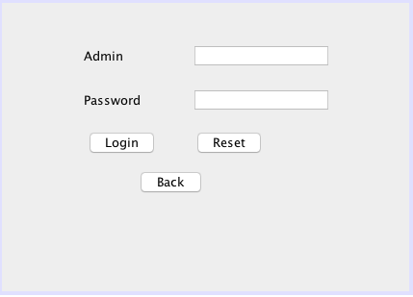
ADMIN LOGIN

Figure 5.1 Admin Login

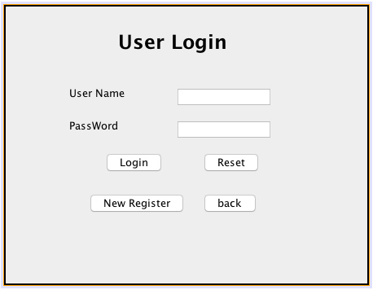
USER LOGIN

Figure 5.2 User login

20
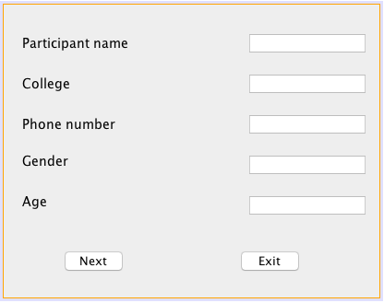
USER REGISTER

Figure 5.3 User register

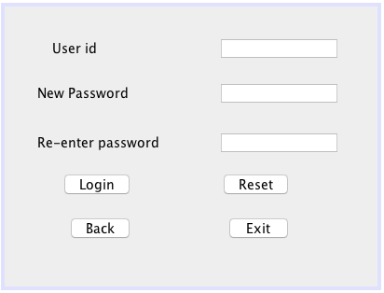
USER SIGNUP

Figure 5.4 User signup

21

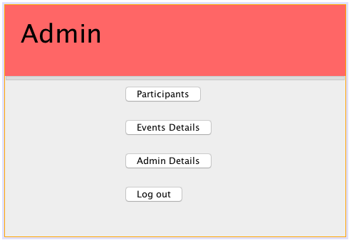
ADMIN SERVICES

Figure 5.5 Admin Services

USER SERVICES
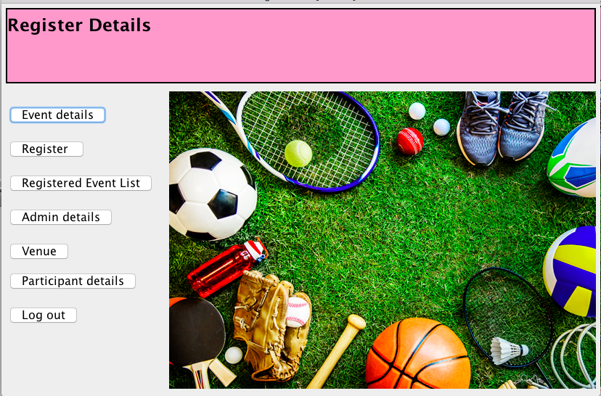

Figure 5.6 User Services

22
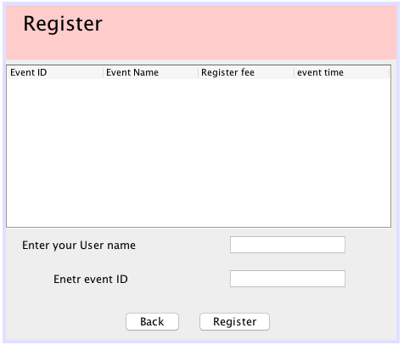
EVENT REGISTER

Figure 5.7 Event Register

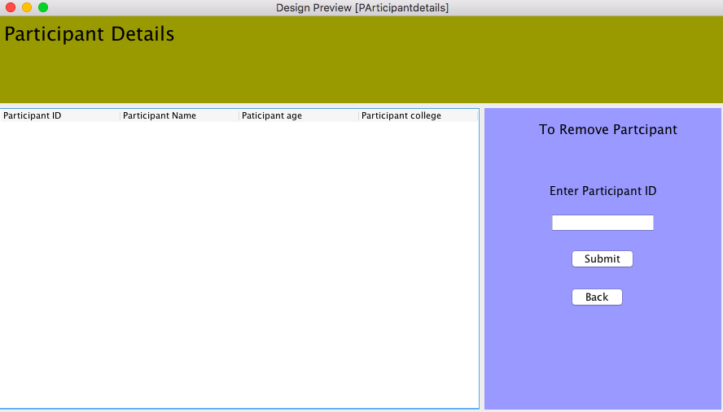
PARTICIPANT DETAILS
Figure 5.8 Participant Details

23
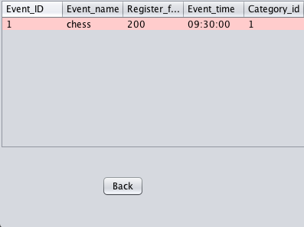
EVENT DETAILS

Figure 5.9 Event Details
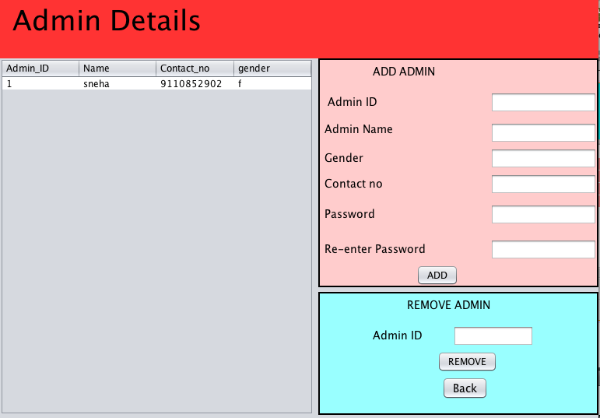
ADMIN DETAILS

Figure 5.10 Admin Details

24

CHAPTER
CONCLUSION

Sports Event management computerization is “the incorporate of appropriate technology to help administrator manage information. Technology is considered appropriate, when it utilizes the most abundant domestic resources and conserves capital and skilled personnel”. Nowadays, people are very busy and they don’t find much time to go to a dealer to get products. But they need to buy products. And most of the people are accessing Internet. Then why don’t we help them in searching & getting products online. Of course this is helpful for company & dealer also to improve the sales.

25
REFERENCES

- [1].Database system models,languages, design and application programming, RamezElmasri and Shamkhat B.Navathe, 7th Edition, 2017, Pearson.

- [2].Database management system, Ramakhrishnan, and Gehrke, 3rd edition,2014,MC Graw Hill .

- [3].Silberschatz Korth and Sudharshan, database system concepts, 6th edition,MC Graw Hill,2013.

- [4].Coronel,Morris,and Rob,database principles fundamentals of design,implementation and management,Cengage learning 2012.

26

